`st

Maximum team combined age of 64

8 teams will compete

No players over age 16

No competitive teams

For sponsorship opportunities please contact [patrickbrowncurling@gmail.com](mailto:patrickbrowncurling@gmail.com)

To Register:

[patrickbrowncurling@gmail.com](mailto:patrickbrowncurling@gmail.com)

Entry Deadline: November 30, 2024





**Bantam Bonspiel**

**Lunch included!**

**Prizes for top 3 teams!**

**$200 entry fee per team**

**2 x 8-end games**

December 14, 2024

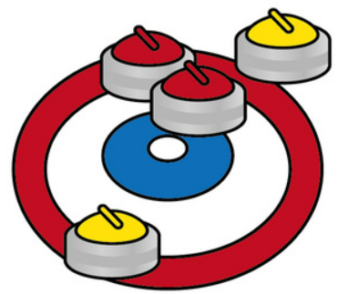

Sponsors

**70 Franklin Street  
Uxbridge, Ontario, CA  
L9P 1J5**

